**Age and Gender Detection using Machine Learning**

***Dissertation Submitted in Partial fulfillment of the***

***Requirement for the Award of the Degree of***

***Master of Technology in Information Technology***

***Semester VII***

***Session: July – Dec, 2023***

**Under the guidance of: Submitted By:**

**Dr. Shaligram Prajapat Sir Alvira Khan (IT-2K20-07)**

**Kunal Bhargav (IT-2K20-27)**

**International Institute of Professional Studies**

**Devi Ahilya Vishwavidyalaya, Indore, (M.P.)**

**2023**

**DECLARATION**

We hereby declare that the project entitled **“Age and Gender detection using Machine Learning”** submitted by us for the partial fulfillment of the requirement for the award of **Master of Technology in Information Technology (5 Years), Semester VII** to International Institute of Professional Studies, Devi Ahilya Vishwavidyalaya, Indore, comprises our own work and due acknowledgement has been made in text to all other material used.

**Signature of Student:**

**Date:**

**Place:**

**CERTIFICATE FROM GUIDE**

It is to certify that we have examined the dissertation on **“Age and Gender detection using Machine Learning”**, submitted by **Ms. Alvira Khan and Mr. Kunal Bhargav** to the International Institute of Professional Studies, DAVV Indore has been completed under my supervision and the work is carried out and presented in a manner required for its acceptance in partial fulfillment for the award of the degree of **“Master of Technology in Information Technology (5 years) Semester VII”.**

**Project Guide**

Signature:

Name:

Date:

**CERTIFICATE**

It is to certify that we have examined the dissertation on **“Age and Gender detection using Machine Learnin**g”, submitted by **Ms. Alvira Khan and Mr. Kunal Bhargav** to the International Institute of Professional Studies, DAVV, Indore and hereby accord our approval of it as a study carried out and presented in a manner required for its acceptance in partial fulfillment for the award of the degree of **“Master of Technology in Information Technology (5 years) Semester VII”.**

**Internal Examiner External Examiner**

Signature**:** Signature**:**

Name:Name:

Date:Date:

**ACKNOWLEDGEMENT**

We, **Alvira Khan** and **Kunal Bhargav**, extend our sincere gratitude to **Dr. Shaligram Prajapat**, our project mentor, for his invaluable guidance, support, and expertise throughout the development of the **“Age and Gender detection using Machine Learning”** project. His insights and encouragement have been instrumental in shaping the project's success. We would also like to acknowledge **International Institute of Professional Studies, DAVV,** for providing the necessary resources and a conducive environment for the completion of this project. The support of the college administration has been crucial to our endeavors.

**With our heartiest thanks to all.**

**Alvira Khan**

**IT-2K20-07**

**Kunal Bhargav**

**IT-2K20-27**

**M.Tech(IT) 5Years**

**VII semester**

**IIPS, DAVV, Indore**

**ABSTRACT**

Accurate age and gender estimation from facial images has gained significant attention in recent years due to its wide range of applications in various domains. Machine learning has emerged as a powerful tool for addressing this task. This project explores the development of a machine learning model for age and gender detection from facial images. The project focuses on data collection and preprocessing, feature extraction, model training, and evaluation. A dataset of facial images with corresponding age and gender labels is collected and preprocessed to ensure consistency and augment the dataset for improved model performance. Relevant features are extracted from the facial images using image processing techniques, considering facial landmarks, wrinkles, skin texture, and hair patterns. A Convolutional Neural Network (CNN) is employed as the machine learning model, trained on the extracted features to classify age and gender. The trained model is evaluated on a testing set to assess its performance using metrics such as accuracy, precision, and recall. The project demonstrates the effectiveness of machine learning in age and gender detection from facial images, achieving atleast 85% accurate results with the trained CNN model.

**TABLE OF CONTENT**

**1.INTRODUCTION**

**1.1 Approaches to Age and Gender Detection 1**

**1.2 Aim 1**

**1.3 Objectives 1-2**

**1.4 Project Goals 2**

**1.5 Benefits 3**

**1.6 Methodology 3**

**2. SOFTWARE AND HARDWARE REQUIREMENT**

**2.1 Software Requirement 4**

**2.2 Hardware Requirement 4-5**

**2.3 Functional Requirement 5**

**2.4 Non- Functional Requirement 5-6**

**3. PROJECT PLANNING**

**3.1 Project Scope 7**

**3.2 Documentation Plan 7**

**3.3 Technology Used 8-9**

**3.4 Team Structure 10**

**4. SYSTEM DESIGN**

**4.1 Layered Architecture 11**

**4.2 UML Diagrams 11-12**

**4.3 Implementation Consideration 12-13**

**5. SOFTWARE DEVELOPMENT METHODOLOGY**

**5.1 Software Project Management Plan 14**

**5.2 Software Design Document 14-15**

**5.3 Specific Requirement Specification 15**

**5.4 Testing Strategy 15**

**6. SYSTEM TESTING 16**

**7. OUTPUTS 17**

**8. SCOPE OF PROJECT 18**

**9. LIMITATIONS 19-20**

**10. CONCLUSION 21**

**11. REFERENCES 22**

**1. INTRODUCTION**

**Problem Definition:** Age and gender detection using machine learning has become increasingly prevalent in various applications, ranging from targeted advertising and marketing to social media analysis and security systems. This technology utilizes machine learning algorithms to analyze facial images, voices, or text-based information to infer an individual's age and gender.

* 1. **Approaches to Age and Gender Detection**

**Feature-based methods:** These methods extract specific features from the input data, such as facial wrinkles, hair texture, and then train machine learning models to classify these features into age and gender categories.

**Deep learning methods:** Deep learning algorithms, particularly convolutional neural networks (CNNs), have gained prominence in age and gender detection due to their ability to extract complex patterns and representations from the input data. CNNs can directly process raw images or audio signals, eliminating the need for manual feature extraction.

* 1. **Aim**

The primary aim of age and gender detection using machine learning is to automatically infer an individual's age and gender from various forms of input data, such as facial images. This technology has gained widespread adoption in various applications due to its ability to provide valuable insights into demographic characteristics and enable personalized interactions.

* 1. **Objectives**

The development of the age and gender detection driven by several key objectives:

**Targeted Advertising:** Age and gender detection can be employed to tailor advertisements to specific demographic groups, enhancing the relevance and effectiveness of marketing campaigns**.**

**Market Research and Customer Segmentation:** By understanding the age and gender distribution of their target audience, businesses can gain valuable insights into consumer behavior and preferences, aiding in product development and market segmentation strategies.

**Personalized User Experiences:** Age and gender detection can be used to personalize user experiences on websites, e-commerce platforms, and social media, providing tailored recommendations and content based on individual preferences.

**1.4 Project Goals**

**Low Latency:**

Achieve minimal processing time to ensure real-time capabilities. Low latency is crucial, especially in applications like video streaming or surveillance where quick responses are essential.

**High Accuracy in Real Time:**

Maintain high accuracy in age and gender predictions despite the real-time constraints. Balancing speed and accuracy is critical for the system's effectiveness.

**Hardware Acceleration:**

Explore the use of hardware acceleration (e.g., GPUs, TPUs) to speed up the processing of age and gender predictions. This can significantly enhance the system's real-time capabilities.

**Adaptive Frame Processing:**

Implement adaptive frame processing to adjust the frequency of predictions based on the availability and relevance of new data. This can help optimize computational resources.

**Robustness to Variable Lighting Conditions:**

Ensure that the age and gender detection model is robust to variations in lighting conditions, as real-world scenarios may involve different levels of illumination.

**1.5 Benefits:**

**1. Targeted Marketing:** Businesses can tailor their marketing strategies more effectively by understanding the age and gender demographics of their target audience.

**2. Enhanced Customer Insights:** Companies can gain valuable insights into the demographics of their customer base, aiding in product development, customer engagement, and overall business strategy.

**3. Security and Access Control:** Age and gender detection can be integrated into security systems for access control, ensuring that certain resources or areas are only accessible to authorized individuals.

**4. Human-Computer Interaction:** It can improve human-computer interaction by adapting interfaces and interactions based on the user's age and gender, making technology more user-friendly.

**1.6 Methodology:**

* **Preprocessing**

**Face Detection:** Employed a pre-trained face detection model to locate faces within the images.

**Image Normalization:** Rescaled and normalized images to ensure consistency in input data.

* **Feature Extraction**

**Facial Landmarks:** Extracted facial landmarks to capture unique features for age and gender prediction.

**Data Augmentation:** Applied augmentation techniques to increase dataset diversity and improve model generalization.

* **Model Architecture**

Designed a Convolutional Neural Network (CNN) for feature extraction.

**2. SOFTWARE AND HARDWARE REQUIREMENT**

**2.1 Software Requirements**

The software requirements for age and gender detection using machine learning depend on the specific implementation and the chosen tools and libraries. However, the general software requirements include:

**Visual Studio Code** is used in this system.

Visual Studio Code provides a powerful and user-friendly environment for Python development, boasting several features that enhance productivity and code quality.

**Python-specific Enhancements:**

**Interactive Python shell:** Experiment with Python code and commands in a live environment directly within VS Code.

**Extension marketplace:** Access a vast collection of extensions for Python testing, code profiling, version control, and more, customizing your development experience.

**Virtual environment integration:** Easily manage and switch between different Python environments and their packages directly within the editor.

**Remote development:** Work on Python code on remote machines or cloud platforms without sacrificing the rich VS Code features.

**2.2 HARDWARE REQUIREMENT**

The hardware requirements for age and gender detection using machine learning depend on the complexity of the models, the size of the dataset, and the desired processing speed. However, some general hardware requirements include:

**CPU:** A decent CPU with multiple cores and sufficient processing power is essential for training and running machine learning models.

**RAM:** Sufficient RAM is necessary to load and process datasets, especially for image-based and voice-based detection.

**Storage:** Adequate storage space is required to store training datasets, preprocessed data, and trained models.

**OS:** Program is tested on Windows 11

**Laptop:** Used to run our code.

**Webcam:** Used to get the video feed

**2.3 Functional Requirements:**

**1.Image Processing:** The system should be able to accept and process input data in the form of facial images.

**2.Feature Extraction and Analysis:** The system should extract relevant features from the input data, such as facial wrinkles, hair texture, or voice pitch, for image-based and voice-based detection, or linguistic features, sentiment analysis, and language models for text-based detection.

**3.Machine Learning Model Training:** The system should allow for the training of machine learning models, such as convolutional neural networks (CNNs).

**2.4 Non-Functional Requirements:**

**1. Performance:** The system should process input data and provide age and gender classification results efficiently, ensuring real-time performance for real-time applications.

**2. Accuracy:** The system should achieve high accuracy in age and gender classification, minimizing misclassification rates and ensuring reliable outcomes.

**3. Scalability:** The system should be scalable to handle increasing volumes of input data and expanding user bases without compromising performance or accuracy.

**4. Robustness:** The system should be robust to variations in input data quality, such as noisy images, distorted voices, or informal text, and maintain accurate classification performance.

**5. Security and Privacy:** The system should implement robust security measures to protect user data privacy, including secure data storage, access control mechanisms, and encryption techniques.

**3. PROJECT PLANNING**

**3.1 Project Scope**

**Goal:** Predict age and gender of individuals in images/videos with high accuracy.

**Data:** Utilize diverse, labeled datasets or real-time video capture.

**Techniques:**

* Deep learning models (CNNs) for Face Detection, Age Estimation, and Gender Classification.
* Transfer learning from pre-trained models to improve accuracy.

**Applications:** Targeted advertising, market research, biometric authentication, accessibility/personalization, entertainment/gaming.

**3.2 Documentation Plan**

Some project documentation will include:

A software requirements specification **(SRS)** is a description of a software system to be developed.

A software project management plan **(SPMP)** document is a well-organized document that contains the project planning in detail.

A software design description (a.k.a. software design document or **SDD**; just design document; also Software Design Specification) is a representation of a

software design that is to be used for recording design information, and addressing various design concerns.

A **test plan** is a document that consists of all future testing-related activities. It is prepared at the project level and in general, it defines work products to be tested, how they will be tested, and test type distribution among the testers.

**3.3 Technology used:**

**3.3.1 Programming Language:**

The programming language involved in this project is **Python**.

Python is a very powerful and highly versatile general-purpose language. It is an interpreted, interactive, object-oriented and high-level programming language. It is the primary language used for developments in data science, machine learning, deep learning and artificial intelligence, due to its easy to read and learn syntax and vast libraries. Python is used in deep learning due to its concise and readable code.

**Advantages of using Python:**

**1. Versatility:** Python is a general-purpose programming language that can handle various tasks, including data manipulation, machine learning model development, and web development. This versatility makes it well-suited for age and gender detection projects, which often involve multiple steps and integrations.

**2. Ease of Use:** Python is known for its beginner-friendly syntax and extensive documentation, making it easier for developers to learn and implement machine learning algorithms. This is particularly beneficial for age and gender detection projects that may involve individuals with varying levels of programming expertise.

**3. Extensive Libraries:** Python boasts a rich ecosystem of machine learning libraries, such as OpenCV, TensorFlow, PyTorch, and Scikit-learn, which provide powerful tools for developing and training age and gender detection models. These libraries offer pre-built algorithms, optimization techniques, and visualization tools, simplifying the development process.

**Machine Learning Libraries:** TensorFlow, PyTorch, Scikit-learn, or OpenCV are popular libraries for developing and training machine learning models.

**3.3.2 Python library**

The main Python library involved in this Project is:

**OpenCV:**

The OpenCV, stands for Open Computer Vision Library of Python, enables users to extract data

using real time computer vision. It is a large open-source library for computer vision, machine

learning, and image processing.

Computer vision is a process by which we can understand the images and videos, how they are stored and manipulated. Computer vision is mostly used in Artificial Intelligence. Computer

Vision has played a major role in self-driving cars, robotics, as well as photo correction apps.

**Advantages of using OpenCV:**

**Image Processing Capabilities:** OpenCV is a specialized library specifically designed for computer vision tasks, including image processing, feature extraction, and object detection. This makes it an ideal choice for age and gender detection projects that rely on facial image analysis.

**Real-time Performance:** OpenCV is optimized for real-time applications, enabling it to process and analyze image streams efficiently. This capability is crucial for age and gender detection systems that require quick responses in real-time scenarios.

**Cross-Platform Compatibility:** OpenCV is a cross-platform library, allowing it to run on various operating systems, including Windows, macOS, and Linux. This compatibility ensures that age and gender detection applications developed using OpenCV can be deployed on a wide range of devices and platforms.

**3.4 Team Structure:**

**Age and Gender detection using Machine Learning**

**(Project)**

**Internal Guide**

**(Dr. Shaligram Prajapat)**

**Software Developer**

**(Alvira Khan)**

**(Kunal Bhargav)**

**4. SYSTEM DESIGN**

The proposed age and gender detection system adopts a layered architecture comprising the

following components:

**4.1 Layered Architecture:**

**1. Data Acquisition Layer:** This layer handles the acquisition and preprocessing of input data, including image normalization.

**2. Feature Extraction Layer:** This layer extracts relevant features from the preprocessed input data, such as facial features.

**3. Machine Learning Model Layer:**  This layer houses the trained machine learning models CNNs responsible for age and gender classification.

**4. Classification Layer:** This layer performs the actual classification of individuals based on the extracted features and the trained machine learning models.

**5. Presentation Layer:** This layer provides a user interface or API for interacting with the system, allowing users to input data, receive classification results, and manage the system's configuration.

**4.2 UML DIAGRAMS:**

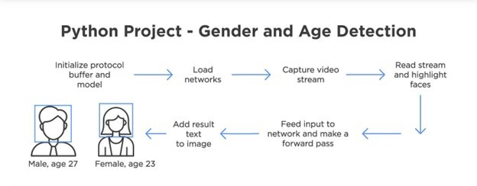

**Figure1**

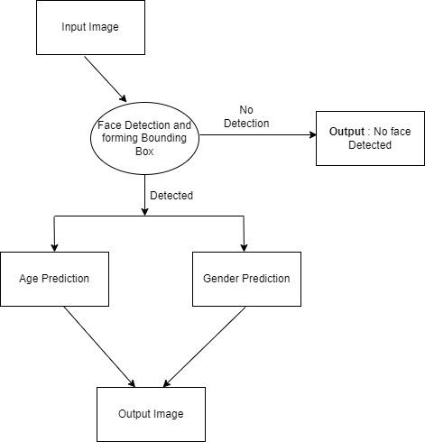

**Figure2**

**4.3 Implementation Considerations:**

The implementation of the age and gender detection system should consider the following factors:

**1. Data Collection and Preparation:** Gathering a diverse and balanced dataset with corresponding age and gender annotations is crucial for training accurate machine learning models.

**2. Model Selection and Training:** Selecting appropriate machine learning algorithms or deep learning architectures based on the input data modality and optimizing hyperparameters are essential for achieving optimal performance.

**3. Evaluation and Refinement:** Evaluating the trained models on a separate validation dataset to assess accuracy and identify potential biases is vital for ensuring reliable classification.

**4. Deployment and Integration:** Integrating the trained models into real-world applications, such as targeted advertising platforms, social media platforms, or security systems, requires careful consideration of system architecture and integration points.

**5. Ethical Considerations:** Addressing ethical concerns related to privacy, data protection, and potential biases in the use of age and gender detection technology is paramount for responsible implementation.

**5. SOFTWARE DEVELOPMENT METHODOLOGY**

**Project Development Steps:**

**5.1 Software Project Management Plan**

**Scope:** Develop a machine learning model to accurately detect age and gender from facial images.

**Schedule:**

Phase 1: Data Collection and Preprocessing

Phase 2: Feature Engineering and Model Selection

Phase 3: Model Training and Evaluation

Phase 4: Deployment and Testing

**Resources:**

Team of 2 machine learning engineers.

1 project manager.

Access to high-performance computing resources.

**5.2 Software Design Document**

**System Architecture:**

**Input:** Facial images

**Processing:**

**- Feature extraction:** Extract relevant features from facial images.

- **Model prediction**: Apply trained machine learning model to predict age and gender

**Detailed Component Design:**

**Data preprocessing pipeline:** Handles image normalization, resizing, and augmentation.

**Machine learning model:** Implements a deep learning model (e.g., CNN) for age and gender classification.

**5.3 Specific Requirement Specification**

**Functional Requirements:**

* Accurately detect age with a mean absolute error (MAE) less than 5 years.
* Accurately detect gender with an accuracy of at least 85%.

**Non-Functional Requirements:**

**Latency:** Process facial images within 1 second.

**Scalability:** Handle large volumes of facial images efficiently.

**Robustness:** Perform well under varying lighting conditions and facial expressions.

**5.4 Testing Strategy:**

* Define test cases for each functional and non-functional requirement.
* Execute test cases and track results.
* Document test results and identify areas for improvement

**6. SYSTEM TESTING**

**1. Data Preparation:**

* **Dataset Split:** Ensure you have properly split your dataset into training, validation, and test sets. The test set should be unseen by the model during training and validation.
* **Preprocessing:** Apply the same preprocessing techniques used during training to the test set images/videos. This includes resizing, normalization, and any other relevant transformations.

**2. Evaluation Metrics:**

* **Accuracy:** This is the most common metric, but it can be misleading for imbalanced datasets.
* **Mean Absolute Error (MAE):** This is a robust metric for age estimation tasks, as it focuses on absolute differences rather than just correct/incorrect predictions.

**3. Testing Methods:**

* **Static Images:**Test your model on individual images from the test set. This helps to identify general performance and potential biases.

**4. Analyzing Results:**

* Analyze the chosen evaluation metrics for both gender and age prediction.
* Visualize the predictions on test images/videos to identify any patterns or biases.

**5. Further Considerations:**

* **Real-time Performance:** Optimize your model for real-time inference on platforms like webcams or mobile devices. This may involve model quantization or other techniques.

**7. OUTPUTS**

**Output: Face Scaling**

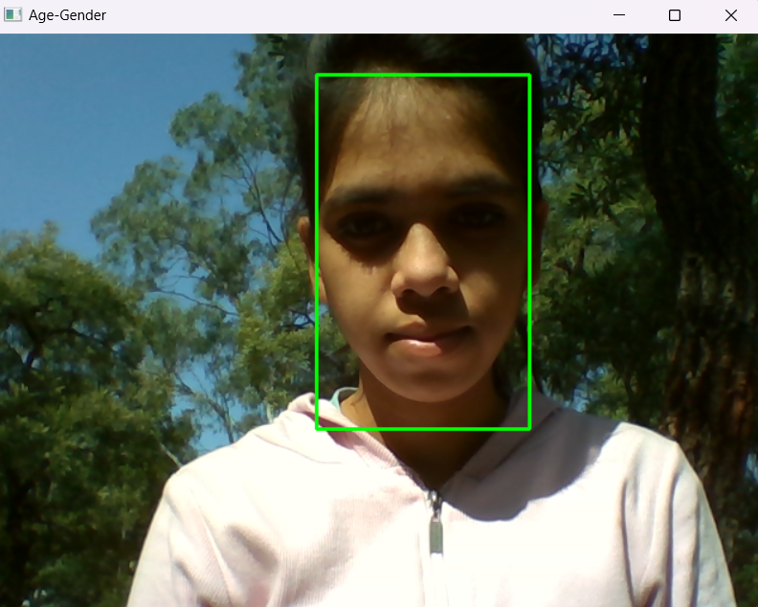 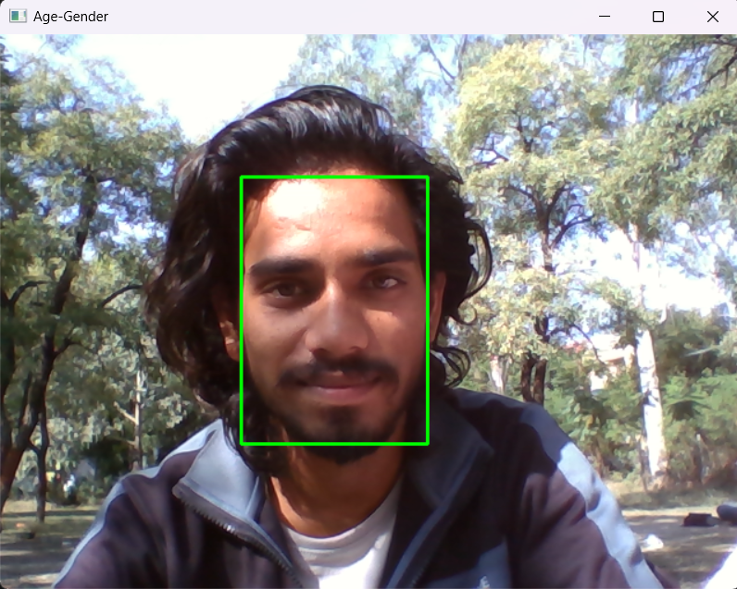

**Output: Age and Gender labels**

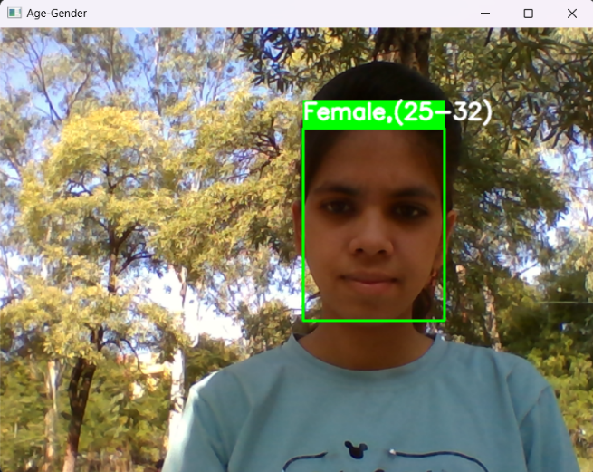 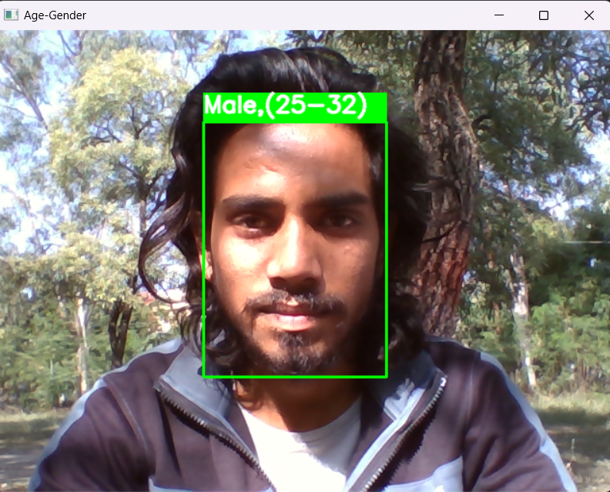

**8. SCOPE OF PROJECT**

This project aims to develop a system that uses machine learning to automatically detect and estimate the age and gender of individuals in images for the purpose of report generation.

**Project Scope:**

**1. Enhanced Security and Identification:**

* **Biometric authentication:** Integrating real-time age and gender detection with facial recognition can strengthen security systems by adding an extra layer of verification.
* **Age-restricted access control:** Public spaces like bars or gambling areas can utilize real-time detection to enforce age restrictions automatically.

**2. Enhanced User Experience:**

* **Smart environments:** Smart homes and offices can personalize settings and recommendations based on the occupant's age and gender, creating a more comfortable and convenient environment.
* **Augmented reality filters:** Real-time age and gender detection can be used to create more interactive and personalized AR filters and experiences.

**Additionally, the future of real-time age and gender detection might involve:**

* **Emotion recognition and sentiment analysis:** Integrating real-time emotion and sentiment analysis alongside age and gender for a more nuanced understanding of user behavior and preferences.
* **Applications in healthcare and medicine:** Age and gender detection can be used for real-time health monitoring or early disease detection based on facial features.

This project scope defines a comprehensive framework for developing a robust and practical system for age and gender detection using machine learning, with a specific application in report generation. By successfully completing this project, we can contribute to the advancement of AI technology and unlock its potential for optimizing and enhancing various reporting processes across diverse industries.

**9. LIMITATIONS**

Age and gender detection using machine learning models, while promising, faces several limitations that need to be carefully considered when deploying and interpreting results. These limitations stem from the inherent biases and challenges associated with data collection, model training, and real-world application.

**List of limitations which is available in the Age and Gender detection using Machine Learning:**

**1. Data Bias and Fairness:**

**Under representation:** Machine learning models are trained on large datasets of facial images. If these datasets are biased towards certain demographics, such as race, ethnicity, or gender, the model may not generalize well to other populations. This can lead to inaccurate predictions and perpetuate existing biases.

**Privacy Concerns:** Collecting and using facial images for machine learning raises privacy concerns, especially when the data is collected without explicit consent or used for commercial purposes.

**2. Model Accuracy and Robustness:**

**Accuracy Variability:** The accuracy of age and gender detection models can vary significantly depending on factors such as image quality, lighting conditions, facial expressions, and cultural norms. This can lead to misclassifications, particularly for marginalized groups.

**Noise and Distractions:** Models may struggle to perform accurately when dealing with noisy images or when faces are obscured by accessories or facial coverings.

**3. Real-World Application Challenges:**

**Social Implications:** Age and gender detection algorithms can be misused for discriminatory practices, such as targeting advertising or denying access to opportunities based on predicted demographics.

**Explainability and Transparency:** The complex nature of machine learning models can make it difficult to understand how they arrive at their predictions, hindering accountability and trust.

**4. Technical Challenges:**

**Data Collection and Annotation:** Collecting and annotating large datasets of facial images with accurate age and gender labels is a resource-intensive and time-consuming task.

**Computational Complexity:** Training and deploying machine learning models for age and gender detection can be computationally expensive, requiring specialized hardware and expertise.

**10. CONCLUSION**

Age and gender detection using machine learning presents a promising approach for various applications, including demographic analysis, marketing personalization, and user authentication. However, it is crucial to acknowledge and address the limitations associated with these techniques to ensure their ethical, fair, and responsible implementation.

**Key takeaways:**

**Data quality and diversity:** The accuracy and fairness of machine learning models depend heavily on the quality and diversity of the data used for training. Efforts should be made to collect and utilize representative datasets that reflect the demographics of the target population.

**Model transparency and explainability:** Developers and users should strive to understand and explain the decision-making processes of machine learning models to promote trust and accountability. This includes identifying potential biases and limitations in the model's predictions.

**Ethical considerations:** The use of age and gender detection technologies should be guided by ethical principles, respecting privacy, non-discrimination, and human dignity. Clear guidelines and regulations are needed to govern the responsible use of these technologies.

**Continuous monitoring and improvement:** Machine learning models should be continuously monitored and evaluated for accuracy, fairness, and potential biases. Regular updates and improvements should be made to address any issues that arise.

**11. REFERENCES**

[**https://pypi.org/**](https://pypi.org/)

[**https://pypi.org/project/opencv-python/**](https://pypi.org/project/opencv-python/)

[**https://pyimagesearch.com/2017/11/06/deep-learning-opencvs-blobfromimage-works/**](https://pyimagesearch.com/2017/11/06/deep-learning-opencvs-blobfromimage-works/)

[**https://www.analyticsvidhya.com/blog/2021/06/learn-how-to-implement-face-recognition-using-opencv-with-python/**](https://www.analyticsvidhya.com/blog/2021/06/learn-how-to-implement-face-recognition-using-opencv-with-python/)

[**https://github.com/smahesh29/Gender-and-Age Detection/blob/master/gender_deploy.prototxt**](https://github.com/smahesh29/Gender-and-Age%20Detection/blob/master/gender_deploy.prototxt)

[**https://github.com/smahesh29/Gender-and-Age-Detection/blob/master/gender_net.caffemodel**](https://github.com/smahesh29/Gender-and-Age-Detection/blob/master/gender_net.caffemodel)

[**https://github.com/smahesh29/Gender-and-Age-Detection/blob/master/age_deploy.prototxt**](https://github.com/smahesh29/Gender-and-Age-Detection/blob/master/age_deploy.prototxt)

[**https://github.com/smahesh29/Gender-and-Age-Detection/blob/master/age_net.caffemodel**](https://github.com/smahesh29/Gender-and-Age-Detection/blob/master/age_net.caffemodel)

[**https://github.com/smahesh29/Gender-and-Age-Detection/blob/master/opencv_face_detector.pbtxt**](https://github.com/smahesh29/Gender-and-Age-Detection/blob/master/opencv_face_detector.pbtxt)

[**https://github.com/smahesh29/Gender-and-Age-Detection/blob/master/opencv_face_detector_uint8.pb**](https://github.com/smahesh29/Gender-and-Age-Detection/blob/master/opencv_face_detector_uint8.pb)